St. Paul Annual Meeting Agenda
_________________________________________________
February 22, 2026
“Responding to God’s grace in Christ, we welcome all people, prepare disciples, and
live faithfully through worship, spiritual growth, and action.”

Call to Order - President Troy Gwinner

Devotions - Pastor Erick Swanson

Approval of Agenda

Approval of Minutes…………………………………..……………………………………………….…………..3
Minutes from Annual Meeting - January 25, 2026

Financial Reports - Wayne Martens and Steve Dick……………………….………………...……4-10
- Treasurer’s Report, including Capital Campaign
- Balance Sheet January 31, 2026
- Profit and Loss vs Budget February 1, 2025 - January 31, 2026
- Audit Committee Report February 1, 2025 - January 31, 2026

New Business……………………………………………………………………………………………………………..11
- Election of Congregation Council Members
- Election of Trust Fund Members
- Election of Nominating Committee Members
- Election of Voting Members of Synod Assembly
- Constitution Changes Ratification - C. 13.04 Mutual Ministry Committee
- Approval of 2026-2027 Budget

Pastor’s Report - Pastor Erick Swanson…………………………………..…………………….………..12-14

President’s Report -Troy Gwinner…………………….……………….…………………………………….15
Synod Report.…………………………………………………………………………………………………………..15

Committee Reports:
1. Property Report …………………………….……………….……………………………………….…….15
2. Safety Team Report.............................................................................................16
3. Memorial Fund Report…………….………………………………..………………………………..….16
4. Trust Fund Report…………………………………………………….…….……………………………….17

Ministry Team Reports:
1. Worship (see written report)………………………………………………..………….………...…18-19
2. Altar Guild (see written report)………………………………………..………………….…..…...19
3. Adult Faith Formation (see written report)……………………………………..…….…….….19
4. Children & Youth Ministry (see written report)…………………………….…..….….…..…20
5. Fellowship (see written report)..........................................................................20
6. Flock Ministry (see written report)......................................................................20
7. Furniture Ministry (see written report)………………………………………………………......21
8. Blood Drive (see written report)..........................................................................22
9. Quilters (see written report)…………………….………………………………………….……....…22
10. Transportation Ministry……………….…..…………………………………………..…….….……….22
11. Pool of Siloam (see written report)……………………………………………….......…..…......22-23
12. Matthew 25: Ministries (see written report)…………………………………..…….…………23
13. Landscaping…………………………………………………………………………………………….……..23
14. Community Garden……………………………………………………………………………….………..24

Close with the Lord’s Prayer

CALL TO ORDER- President Troy Gwinner

DEVOTIONS- Pastor Erick Swanson

Approval of Agenda

Approval of Minutes: 1/25/26
Present: Ted Leonard, Jason Darling, Bill Chrisman, Barb Kellogg, Dick Anderson Absent: Liz Hansen. Bill called the meeting to order.
Minutes from the last meeting were approved by Jason. Ted seconded the motion. Motion was voted on and carried. An impromptu meeting was held on 11/16/25 to discuss the storage unit rent due for the Furniture ministry. The church currently rents 3 units. (Note: In the past, the church rented 2 units and also used Jim Nelson’s garage, which is no longer available.) Ted made a motion to pay the bill for the full year’s rent (Nov 2025 thru Oct 2026) of $3,122.90. Liz seconded the motion. Motion was voted on and carried. Dick distributed copies of the Trust Fund financials to the group. The Fidelity Investment Account balance as of 1/25/2026 was $224,986.46 and the checking account balance was $925.94. Jason made a motion to approve the treasurer’s report. Ted seconded the motion. Motion was voted on and carried. The church plans to participate in packing meals at the church, again this year, for Meals from the
Heartland. Jason made a motion to cover the full cost of $3,500. Ted seconded the motion. Motion was voted on and carried.
The Junior High School is requesting help for the kids to pack meals at the school, for Meals from the Heartland. Ted made a motion to give $500 to the project. Jason seconded the motion. Motion was voted on and carried. Ted made a motion to approve the following requests, seconded by Barb. Motion was voted on and carried.
1. $1,000 to MATURA
2. $500 to CRISP
3. $500 to Paw Pantry
Ted made a motion to give $1,000 to Hearts in Motion, seconded by Jason. Motion was voted on and carried. The next Trust Fund meeting will be Sunday, April 26, 2026, right after service. Barb motioned to adjourn the meeting. Meeting adjourned by Bill.

*Financial Reports
1. Treasurer’s Report
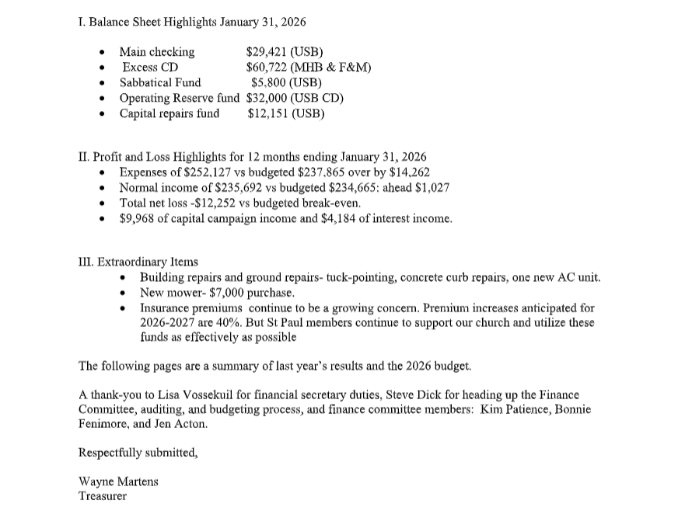

2. Balance Sheet

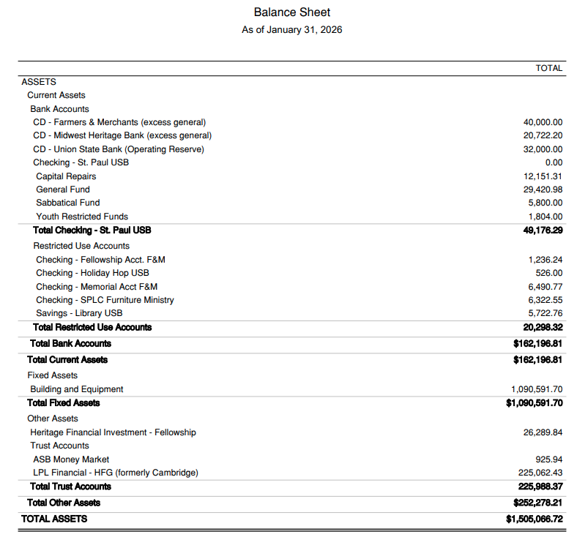
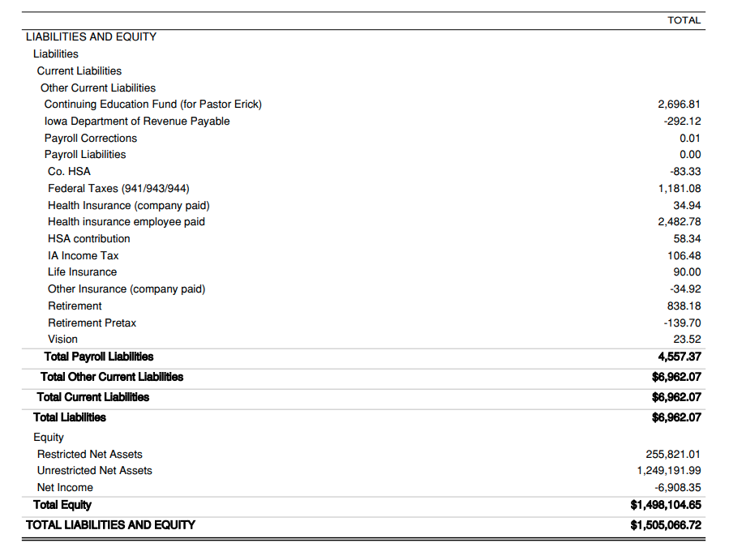

3. Profit and Loss vs Budget (February 1, 2025 - December 31, 2025)
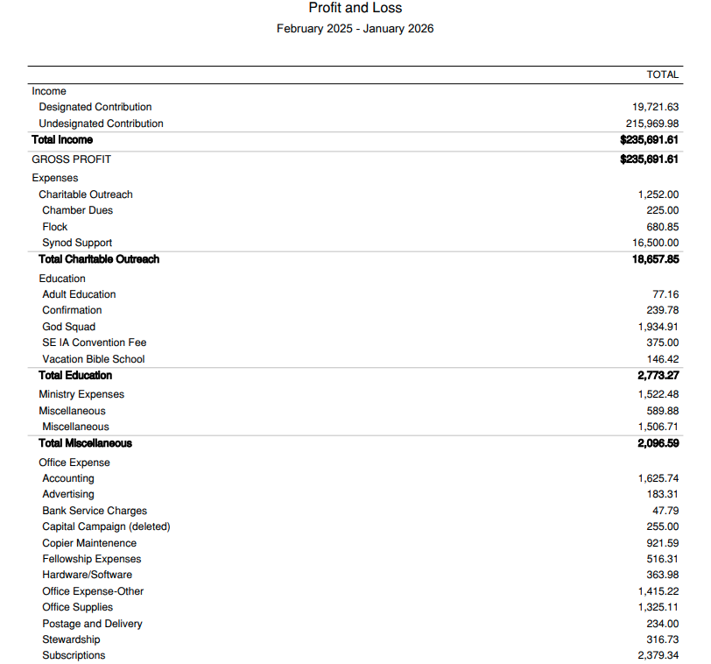
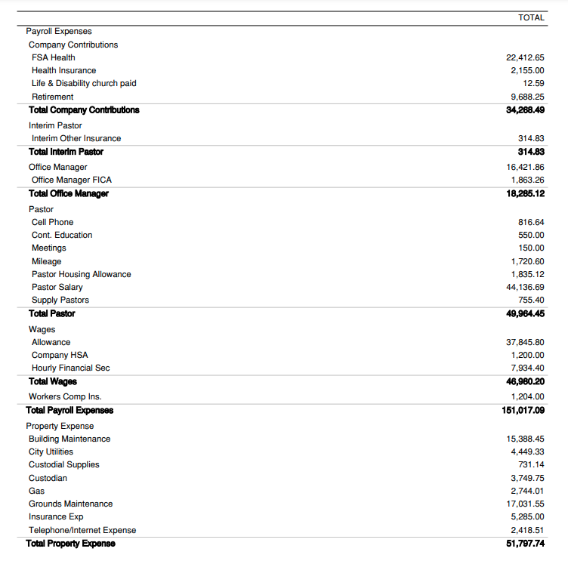
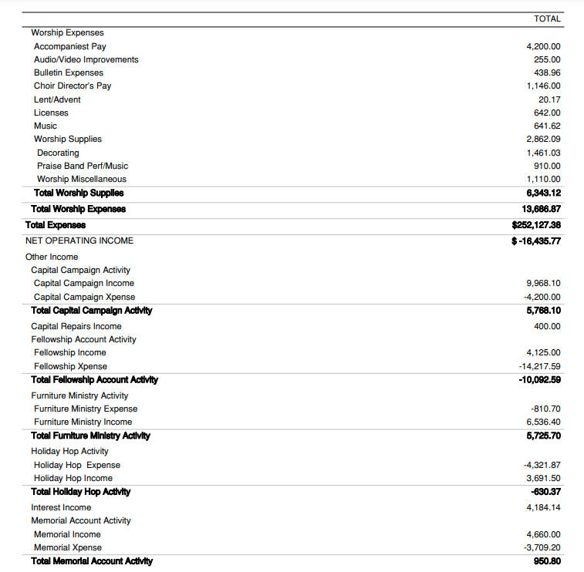
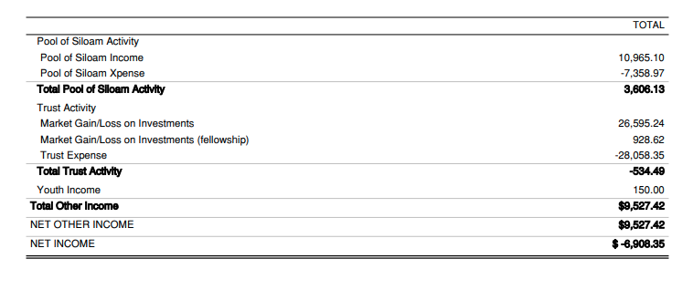

4. Audit Committee Report - Committee: Steve Dick, Bonnie Fenimore and Barb Stiles (Steve Wetlaufer absent) Church Staff: Lisa Vossekuil
On Sunday, February 15, 2025, the Audit Committee reviewed the church financial documents. We performed the following verifications and looked at a sampling of transactions from each of the bank accounts:
1) Tied all bank balances on the Balance Sheet on 2/1/2024 and 1/31/2025 back to the bank statements.
2) Reviewed the General Ledger transactions to ensure that they were proper to the bank account and nothing appeared as checks written to cash
3) Tested a sample of transactions in each bank account back to ensure that there was supporting documentation for the transaction (paid to the correct vendor for the documented amount), that it was properly approved, and that it was part of the proper bank account (Deposits/Expenditures/Payroll)
4) Traced all transfers between accounts affected and looked at appropriateness as such
Overall, the financial statements and records were in very good shape. We found 1 bank account that was missing a small entry from January (did not materially misstate the balance). We found one transaction that we reviewed that we could not locate the supporting documentation, however we did have enough information to document appropriateness and legitimacy of the entry. All transactions appeared appropriate for church activities in the given bank account. The audit committee has the following recommendations:
1) No checks should be made payable to and signed by the same person. None of the transactions were suspicious in any manner and were properly documented, but best practice would be to avoid this and have someone else sign the check as needed.
2) All checks in all accounts should have a description of what is being purchased in the memo line of the check, especially for those accounts with separate checkbooks, such as Fellowship, Memorial, Holiday Hop and Trust accounts.
3) Documentation should be kept for all transactions, including returns. All documentation should clearly identify what good/service was being purchased/returned. If not clear, a hand written note should be present that would clearly identify it.
4) All statements provided to the financial secretary for “other” bank accounts should include the pages with the copies of the checks and deposits and not just the front sheet showing the net activity of the account and current bank balance.
Thanks to the Audit Committee members and for Lisa for taking the time to perform this important task to ensure that St. Paul’s financial statements are accurate and adequate supporting documentation is being maintained for all transactions for all of the church’s bank accounts.
Steve Dick, Audit Committee Chair

*New Business

Election of Council, Committees, and Synod Representatives We of the nominating committee - Ann Bartelt, Troy Gwinner, Cheryl Young, Beth Sunds and Ted Leonard - submit to the congregation the following persons for election to the following as listed:
- Congregation Council 2026-2029:
  - Sydney Conrad Cook
  - Kendrick Blanchard
  - Amanda Turnquist
- Trust Fund Committee 2026-2029:
  - Brenda Hollingsworth
  - Ted Leonard
- Nominating Committee 2026-2028:
  - John Patience
  - Dave Brakhane
- Synod Representatives 2026:
  - Leon Schwartz
  - Miriam Lutz

Approval of 2026-27 Budget
How St. Paul will do ministry in 2026
Our St. Paul Lutheran budget does a couple important things. First, the budget tells how we will use our financial resources to do ministry in service to Christ during 2026. Members of our budgeting team and the Council gather information, consider priorities and changes, and build a financial plan to support our ministry.
Second, a budget provides visibility and accountability. Together, we all have a role in reviewing and approving our financial plan. Then, our Council works throughout the year to carry out good and faithful ministry, working within our budgeted plan.
2026 Budget Categories Amount
Pastor & Staff $ 158,410.00
Property & Utilities $ 31,750.00
Synod & Mission Support $ 17,700.00
Worship & Music Ministry $ 13,110.00
Office & Admin. Expenses $ 9,035.00
Christian Education $ 4,000.00
Stewardship $ 650.00
Total 2026 Proposed Budget $ 234,655.00

Let us pray
God of abundance, look with favor on what we offer here. Use us and all the gifts we bring to do your work and your will in our community and in our world. May our financial gifts and this ministry we share be a holy offering, pleasing to you, our Lord. We ask this in Jesus’ name. Amen.

*Pastor’s Report- Pastor Erick Swanson
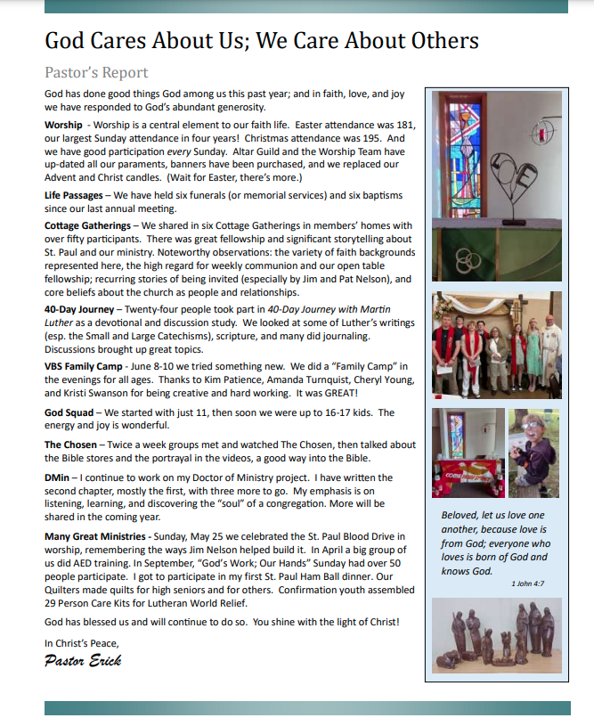
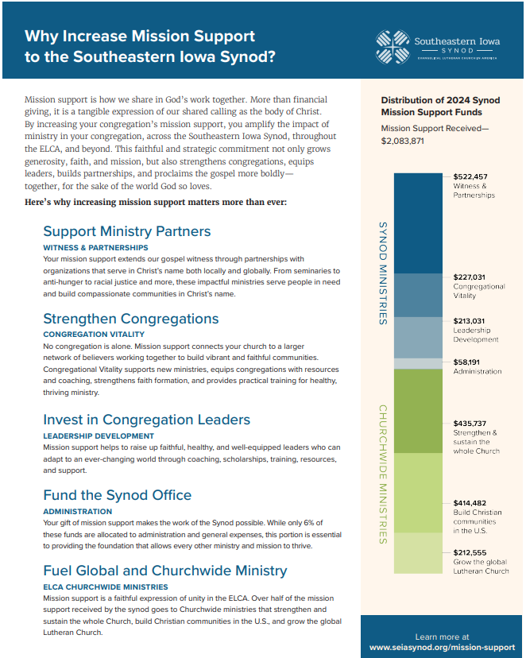
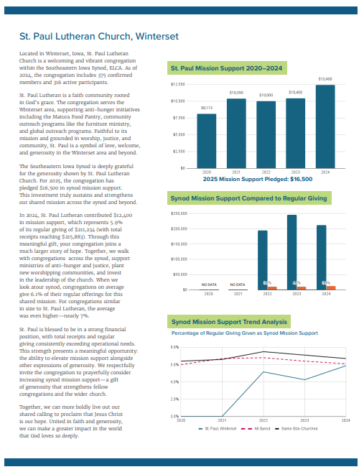

*President’s Report- I wanted to thank the congregation for your time, donations and commitment to our church. It takes everyone to make the church run and grow. The thoughts, ideas and actions of everyone helps make this church prosper. Troy Gwinner

Synod Assembly Report 2025. Attendees: Darrell & Lisa Vossekuil, Pastor Erick Swanson & Kristi Swanson (guest). This year Synod Assembly was reduced from a 2-day experience into 1 day and was held on the campus of Grand View University in downtown Des Moines. The day was jam-packed with synod reports to accept including the minutes from last year’s assembly, financial reports, secretary’s report, Amy Current’s Bishop report and others. We were also informed about the total increase in total compensation package for employees is 7.35%. Because of it only being a one-day event, there were no breakout opportunities and those are the sessions that Darrell and I get the most out of, as well as getting the chance to report back to the congregation on what those breakouts were about.
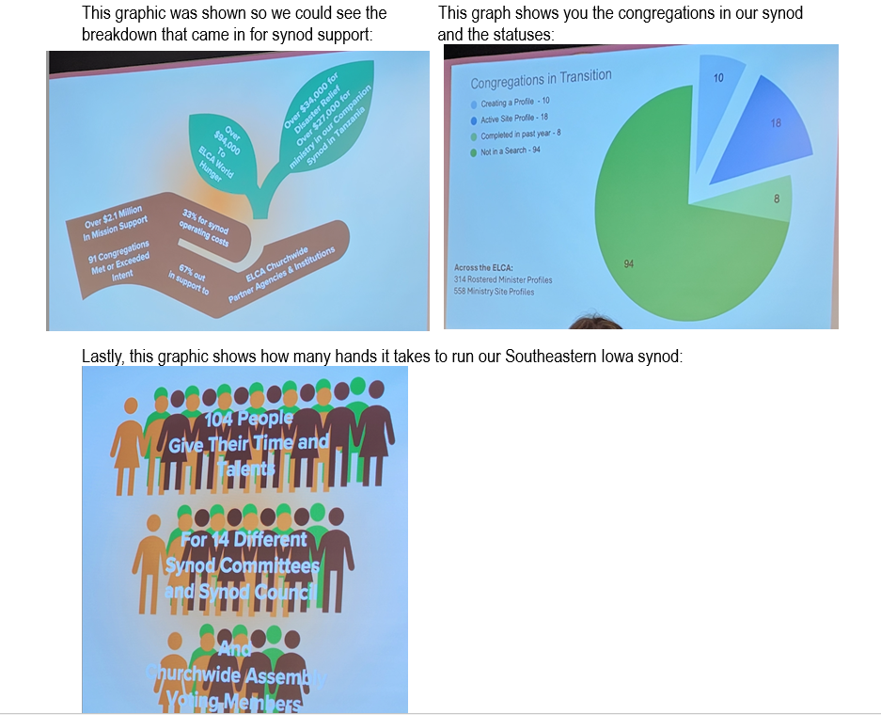

*Committee Reports

Property: Like to thank Tony Burkett for chairing the building committee last year. Mark Kenyon has been elected to serve as chairman of the property board. Thanking everybody on the mowing crew. The lawnmower has been tuned up and ready to go for the year. New year needs volunteers to help pull weeds in the landscaping around the building flower beds. Last year the building committee extended the handrailing at the main entrance and redid the half circle driveway by filling the cracks and putting a new sealer on the asphalt. Set up a company to reseal around the windows and the cracks in the cement part of the building on the west side and south side of the building. We helped re-organize and put new brass nameplates on the mailboxes. Also numerous little things around the church. If you see something that needs to be addressed, please say something to our property board or the office.
Safety Team: No new items to report. Cheryl Young

Memorial Fund Report: FEBRUARY 1, 2025 - JANUARY 31, 2026

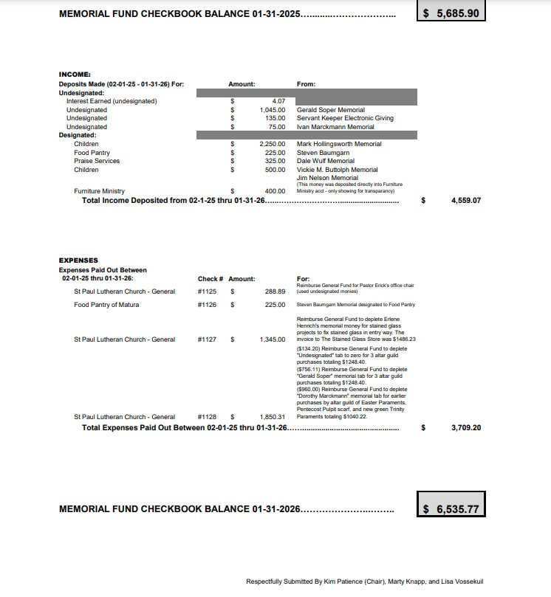
Trust Fund: Jan. 31, 2026
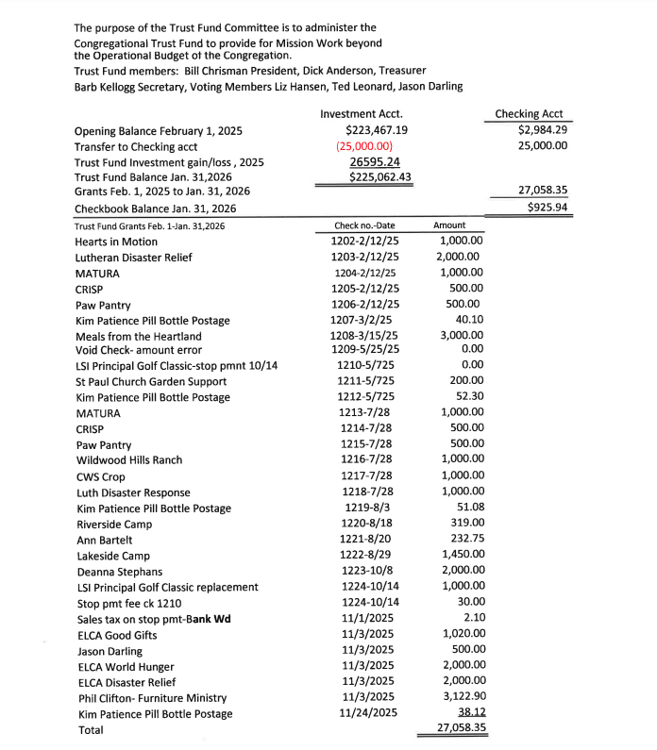

*Ministry Team Reports:

Worship: St Paul Worship Committee Annual Report – February 22, 2026.As Chair of the Worship Committee, I am pleased to present this annual report on behalf of our dedicated team. Over the past 6 months,, we have worked collaboratively to enrich our worship experiences, foster community, and deepen our faith journey. Our committee members—Beth Sunds (Chair), Debi Martens, Georgine Bellamy, Lisa Vossekuil, Darlene Loiler, Pastor Erik Swanson, and Kara Ellingrod (Council Liaison)—have brought passion, creativity, and commitment to every initiative. Together, we have navigated seasonal transitions, celebrated milestones, and embraced opportunities to make our services more exciting and engaging. This report highlights our accomplishments, reflects on the blessings we've shared, and outlines exciting plans for the year ahead. We are grateful for the support of our congregation and look forward to continuing this vital ministry with renewed energy.
Accomplishments: To enhance our visibility and outreach, we updated the community signage leading into Winterset with our current logo, ensuring a welcoming presence for visitors. Additionally, we installed vibrant banners on our property to promote the God Squad, boosting our advertising efforts and inviting more families to join our youth programs.
Our commitment to diverse worship styles shone through with the Rock Solid Praise Band leading services on the first Sunday of every month. These gatherings not only featured exciting new music, but also contemporary wording for the Lord's Prayer and the Confession of Faith, making the liturgy accessible and resonant for all ages.
As summer transitioned to fall, we held a "Blessing of the Backpacks" service, praying over students, teachers, and families returning to school. This event fostered a sense of unity and divine protection for the academic year ahead. In November, our All Saints Service allowed us to light candles in loving memory of those who have gone before us, creating a sacred moment of remembrance and gratitude. We also introduced a new Thanksgiving service during the week of the holiday, gathering to give thanks and reflect on God's abundant blessings.
Shifting from the traditional Lighting of the Greens, we kicked off Advent with an innovative service titled "Prophets and Promise," setting a tone of anticipation and hope. Our mid-week Advent services were particularly special, as families participated by lighting the Advent candles and sharing readings, encouraging intergenerational involvement and strengthening family bonds within our church.
The Christmas season was a highlight, featuring a single candlelight service enriched with an array of special music. The glow of candles and harmonious melodies created an atmosphere of peace and wonder, drawing us into the miracle of Christ's birth. Throughout these efforts, our committee has prioritized creativity and spiritual growth. These accomplishments not only enriched our worship but also built stronger connections among our members, demonstrating the vibrant spirit of our congregation.
Future Plans: Looking ahead, we are excited about opportunities to build on this foundation and address emerging needs. First, we will solidify a communication team in partnership with Pastor Erik Swanson to ensure our news, events, and worship updates reach everyone effectively. This initiative will enhance transparency and engagement, keeping our community informed and involved.
We also plan to discuss and implement changes to better accommodate the Rock Solid Praise band, which requires additional space at the front of the sanctuary. By optimizing our worship layout, we can support their ministry while maintaining a welcoming environment for all.
Finally, we will be intentional about training interested congregants in key roles such as ushering, the readings, and operating sound equipment. This empowerment will broaden participation, distribute responsibilities, and cultivate new leaders within our church family.
Looking Ahead to the Lenten Season: As we reflect with gratitude on God's faithfulness in our recent times of worship and fellowship, we also turn our hearts toward the upcoming Lenten season. We are excited and prayerfully anticipating the opportunity to plan meaningful observances for this sacred time of reflection, repentance, fasting, and renewed focus on Christ's journey to the cross and resurrection. Our worship team and leadership will soon begin discerning themes, special services (such as Ash Wednesday, midweek gatherings) and ways to encourage our congregation in spiritual disciplines that draw us closer to Jesus.
This year, Lent begins on Ash Wednesday, February 18, 2026 (this service will be at the Presbyterian church with Pastor Erick preaching the sermon), continuing with Maundy Thursday on April 2, 2026 (a traditional Lutheran service at our church), leading us prayerfully to a joint Good Friday service with the Presbyterians at our church on Good Friday, April 3, with the celebration at our church for our Easter Service on April 5th, 2026.
Conclusion: In closing, the Worship Committee extends heartfelt thanks to Pastor Erik Swanson, our fellow committee members, and the entire congregation for your unwavering support and participation. Your enthusiasm has made this year truly rewarding, and we are encouraged by the ways God has worked through us. As we move forward, let us continue to worship with open hearts, embracing the call to love, serve, and grow together. May the coming year bring even greater blessings to St. Paul Lutheran Church. With gratitude and optimism,Beth Sunds, Worship Committee Chair

Altar Guild: We had a busy year updating the view you have during worship. Thanks to memorial gifts and others, we now have gold toppers on our altar candles, new paraments in green, white, and red and have new Lenten paraments coming for Lent (purple). We also have a new Christ candle with a new candle holder being made by talented members in our church. Coming up in 2026 we look forward to sharing the joy of serving communion with many more. Let us know when you want to help.
We want to welcome Janelle Croska to the crew, but have plenty of room for more if you are interested. We also have Troy Gwinner and Ted Leonard that serve the common cup. Let us know if you would like to help serve communion or by bringing bread. We can walk you through the duties when your turn comes up. We want your time at the table to be to the glory of our Lord. Our team: Janelle Croska, Bonnie Fennimor, Linda Kenyon, Debi Martens, Kim Patience

Adult Faith Formation: 2025 was a year of many new beginnings for St Paul Lutheran Church. One of those new beginnings happened when Pastor Erick and Kristy began their first Sunday here at St Paul on December 1, 2024. It seemed prudent to the Faith Formation team to step back and let Pastor take the lead. In July and August of 2025 Pastor led a study entitled “Luther a 40 Day Journey.” Each member of the group read the workbook and then met on Tuesday evenings to discuss that week’s lesson. The response ranged from 5 to14 attendees. All who participated felt that the time spent reading and in discussion strengthened their “faith-walk.” Beginning in November, a group of six participants gathered Thursday afternoons to watch the Chosen Video, Season 3. Following the video Pastor led a discussion. There was enough interest that a second group began the same Chosen Video Series on a Tuesday night. Each study/discussion lasted 8 weeks. The Faith Formation Team looks forward to working with Pastor Erick on Faith Formation activities/studies in 2026.
We have 4 tentative events planned for this spring: Puzzle competition, Game day, homemade pie day and ice cream day. First BBQ of the season. Dates and times to be announced. Brenda Hollingsworth and Cheryl Young
Faithfully, Cheryl Young

Children & Youth Ministry: No Report Given

Fellowship: During 2025 the fellowship fund had income from the following sources: Coffee -$764.56, Lent/Advent - $462.00, Funerals - $2850.00, Quilts - $100.00, Donations - $20.00. With total income for the year were $4,196.56.
Expenses were as follows: Coffee -$264.84, Supplies - $625.57, Food (for funerals) - $556.48, Kitchen equipment - $92.83, Fellowship expenses - $435.61. With total expenses of $1975.33.
The fellowship fund also paid for a number of expenses for maintenance of the interior and exterior of the church. These expenses include the following: Kids bags - $221.29, Paraments - $288.84, Senior quilts - $62.96, Building expenses - $12,303.43, Miscellaneous - $10.97. Total expenses were $12,887.49. Our total expenses for the year were $14,862.82. Pat Wetlaufer

Flock Ministry: The purpose of Flock Ministry has changed over the past few years and this year has had a focus on outreach, new members, visitors, and caring on those in need. Chairperson for this committee is Nicole Darling. Currently we have a core committee that also branch out to others in the congregation for specific areas of assistance.
The core Flock members are Nicole Darling, Liz Hansen, Jacque Mohs, Ann Bartelt. Meetings take place when it is needed but most communications are done via email.
As a ministry team, we are constantly trying to do outreach to our visitors, making them feel welcome and addressing any questions they may have. Several contact points throughout our team which entail delivery of baked goods, conversations about what their interests are in the church and spreading the good news of St. Paul.

Two areas that the Flock ministry focuses on are College Care Packages: We ask the congregation to provide food items, $, gift cards, necessity items to the care packages over a 3 week period. Packages are mailed out the first week in December to our current college students as inspiration and support during Finals Week.
The cost of boxes & postage for college care packages are reimbursed by the church
Boxes & packing tape: $25
Postage: $220-$280
===============
~$245-$300

The other area of focus has been “New Member” Installation. Flock ministry has helped coordinate a pastor/member session preparing the new members with education and information regarding St. Paul. Flock also organizes “New Member” Installation with invites and a brunch celebration for the church and its newly installed members after the service.
The cost of providing a reception for the new members and congregation is divided between donations from the Flock committee and from the Flock budget.
Flock Ministry’s Annual Budget request to for 2026 is $500/year. This budget will allow for Flock ministry to continue good work connecting to visitors, new members and stay connected in supporting our college students. Nicole Darling

Furniture Ministry: 02-01-2025 through 01-31-2026
I believe that this past fiscal year was hard for everyone who has helped with the furniture
ministry. Jim and Pat Nelson began this ministry and with Jim’s passing in March of 2025, a
Saturday morning doesn’t go by without me hoping to look up and see him pull up in his white
truck with a smile on his face, ready to drive wherever we needed to be. I am determined to
carry on what Jim and Pat started.
We purchased $265.00 worth of furniture/kitchen appliances this fiscal year at auctions, I paid
for 6 months rent ($545.70) for a storage unit across from the church when we had to remove all
the furniture from Jim’s son, Ryan’s garage because they were selling the house. We received
$5,148.92 from Sunday donations as well as the St Paul Trust Fund paying rent for 4 of the 5 of
the storage units for the year totaling $3,122.90.
I am not sure where the furniture ministry would be without the help from the Trust Fund paying our storage unit rent as well as donations from the congregation. I am humbled by all the help that has been given to keep this ministry going. Jim would be so happy if he could see
the checkbook balance. Thank you!!
As I do every year, I have to include those that volunteer on Saturday mornings to get through
the list of pick-ups and deliveries. There is no way Darrell and I could do this alone. I thank God
every week when I send out the text for help that you always come through to help, even in
below zero temperatures. I think we have a good time together and are a close group while at
the same time, we are helping people in our community. Thank you!!
If you would like to volunteer, please reach out to me: Lisa Vossekuil: (920) 979-0304 | levossekuil@gmail.com
These are the items that we take (bolded are needed the most): Beds (twin, full, queen, baby with simple frames) Small Kitchen Tables/Chairs, Couches (no hide-a-beds) Small kitchen appliances (ie: toasters, coffee makers, etc.), Loveseats Dishes/Pots & Pans/Baking dishes, Lamps Washers/Dryers (electric only), End Tables Microwaves
Occasional Chairs Stoves (electric only), Recliners Refrigerators, Dressers/Chest of Drawers (no mirrors) Drinking Glasses/Cups
Anyone receiving furniture from our ministry is given a flyer that tells them more about our
ministry and invites them to worship on a Sunday morning. For individuals or families to receive items from our St Paul Lutheran Church Furniture Ministry, they must be thoroughly vetted through one of the following organizations in our community, to make sure that their need is real. C.R.I.S.P Crisis Intervention Center Matura (Multi-purpose Center), Churches Schools, Hospital, Turning Point Evaluation Police/Sheriff
YEARLY STATISTICS: Year Families Who Donated To Families We Delivered Monetary
Furniture Ministry Furniture To Donations
2025 62 61 $4,535.00
2024 58 50 $4,535.00
2023 37 42 $3,370.77
2022 27 43 $2,225.00
2021 42 38 $400.00. Submitted by Lisa Vossekuil

Blood Drive: Each month on the fourth Tuesday, St. Paul Lutheran Church hosts a LifeServe community blood drive. We welcome all donors to participate and enjoy some social time with new and old friends while sampling the homemade treats. Homemade treats have been huge draw to bring in blood donors from the community. We get many comments of appreciation every month. We ask for new donations every month since leftovers are served on Sunday mornings during fellowship hour. We have many members that continue to support the drive. They include all the wonderful bakers (too many to mention) who provide cookies and bars, the callers (Genelle Thompson & Liz Hansen) who remind donors of their appointment time, those who set up (Dick Anderson’s team) and breakdown (Wayne &amp; Debi Martens) the tables and chairs, and the canteen staff (Shirley Tallman, Marty Knapp, Naomi Bradbury & Cori Huizinga) who serve the drinks and treats. We are especially grateful for all who willingly roll up their sleeves and provide their life saving contributions. Our average number of units is approximately 40-45. Shirley Tallman

Quilters: We are continuing to quilt every Wednesday morning for 9:00 to 11:00. Everyone is welcome to come and help with this mission for the church. The quilts were have been making have been given to the needs of the surrounding community. We continue to make jean quilts for the graduating seniors of the congregation. Pat Wetlaufer

Transportation Ministry: In 2025 Transportation Ministry has aided 14 people with rides home from Madison County Memorial Hospital emergency room, from outpatient patient surgery at MCMH when no other ride has been available, and transportation when needed for St Paul members to Des Moines doctor appointments. We sure would welcome a few more names for our driver call list. We often don’t know when the ride is needed and need to find someone spur of the moment. If you would be willing to offer transportation occasionally, please speak with Chris Madison or Cheryl Young. (FYI, trucks and other high profile vehicles do not work well for this)

Pool of Siloam: February 1, 2025 through January 31, 2026
Pool of Siloam is St. Paul’s local benevolence program that provides monetary
support for those within Madison County only, in need of such things as gas money
or car repair, rent or mortgage assistance, and utility bills. In partnership with other
local agencies such as C.R.I.S.P., Matura, Crisis Intervention, to name a few, we
annually serve over 50 individuals, including children. Those who designate a part of
their offering to the Pool of Siloam is matched by an anonymous donor.
These are the totals that came in and went out for this past fiscal year:
Pool of Siloam Income: (through congregational support, an anonymous donation and Broadlawns WIC): $10,965.10
Pool of Siloam Expenses: (monies paid out to individuals in need
who have been vetted through organizations such as C.R.I.S.P., Matura, Crisis
Intervention, etc.): $ 7,358.97
Council Approved Changes: This fiscal year, the council approved that the maximum amount given to a person requesting help would not be limited to $300.00 and also there is no longer a one- time request per year. Because of the approved changes, we were able to help more people and those whose request was greater than $300 was granted. This fiscal year the Pool of Siloam has given money in the following areas listed below. 27 individuals and/or families have benefited by this ministry compared to 18 last fiscal year:
8-Rent/Mortgage
3-Vehicle fuel
5-Utilities (Winterset Municipal Utilities)
1-Hotel stay (homeless)
2-Groceries
1-Home Fuel (MidAmerican Energy)
4-Cell phone
1-Day Care
1-Security Deposit
1-Storage unit rent
This would not be possible without your support! THANK YOU!!
Respectively submitted by Lisa Vossekuil

Matthew 25 Ministries: St. Paul Lutheran Church began participating in this ministry in 2023. Matthew 25 Ministries collects many supplies for medical mission trips. Pill bottles are one of the supplies requested. A collection box is located in the entrance hall under the mailboxes for anyone to bring in clean pill bottles. In 2025, St. Paul has collected 1,268 pill bottles and the bottles have been sent to Matthew 25 Ministries in Ashton, Ohio. We have sent a grand total of 3,733 since we started participation in this ministry. Please continue to thank the trust fund for funding the shipping costs. A reminder that labels and sticky residue need to be removed from the bottles. A product called Goo Gone or similar product will greatly help to remove the sticky glue under the labels or just lots of soaking the bottles. The pill bottle should be washed and thoroughly dried with the lid placed back on the bottle. There is a guideline sheet available for more information. If anyone would like to help count and package bottles, please contact KIm Patience. Any teen needing silver cord hours is invited to help too. A big thanks to the congregation for their participation in this ministry. Respectfully submitted, KIm Patience

Landscaping: The St. PAUL exterior landscaping volunteers accomplished much with the cooperation and help of several hands and a few dollars.
Marie Sussman planted the east circle drive area with plantings she purchased.
I created a new Hosta berm in the center of the center circle drive under the trees with over 40 plants. Several shared their hostas.
An area was created to honor Jim and Pat Nelson and also Twila Seibert for their many years of service to Saint Paul. Items from their personal gardens were used in addition to those we added. These 2 displays will continue to evolve.
Trees and shrubs were trimmed and shaped. Roses trimmed, fertilized and deadheaded multiple times, flowers of all kinds given TLC weekly care, watering as needed, etc. Rich T.

Community Garden: The Community Garden area was cleaned up, and a composting pile was started with the assistance of Myron Hirschman this Fall. If you have items to add to the compost pile drop them at the pile and I will get them mixed into the pile. Sign will be coming soon.

2026 will bring many more Spring flowers as the bulbs mature and divide. We need to divide and relocate some perennials. Different, taller summer perennials will be added to the center of the butterfly garden. Our 10 roses are showing their age. We will cut them back more severely this year, giving them an opportunity to re-grow stronger and better. Trees will be trimmed in February/March. New mulch will be added to the flower beds this Spring along with fertilizer and Preen to reduce weed growth when possible.
I appreciate the willingness of our caring hands to help with this work. If you want to spend just an hour 1 time a month working with the flowers it will put a smile on your face and lift your heart as you commune with God! Rich Thompson

*Close with Lord’s Prayer

